**Lesson 15 – Report documenation  
  
Introduction and Purpose**

The classification of this CNN project is between **Tomato vs Apple then Ripe vs Unripe** using Keras model from google teachable machine. The dataset includes more than 3000 tomato images and around 1000 apple images.

With over 4,000 labeled images (3,000+ tomatoes and 1,000+ apples), Teachable Machine allowed us to quickly train and evaluate a CNN model without writing code for data preprocessing, augmentation, or model configuration. It uses pre-trained models under the hood (like MobileNet), making it possible to achieve reasonable accuracy even with a relatively small dataset.

**Mechanism**  
  
Use a **two-stage architecture**:

1. **Stage 1**: Detect fruit type (e.g., apple, tomato, banana)

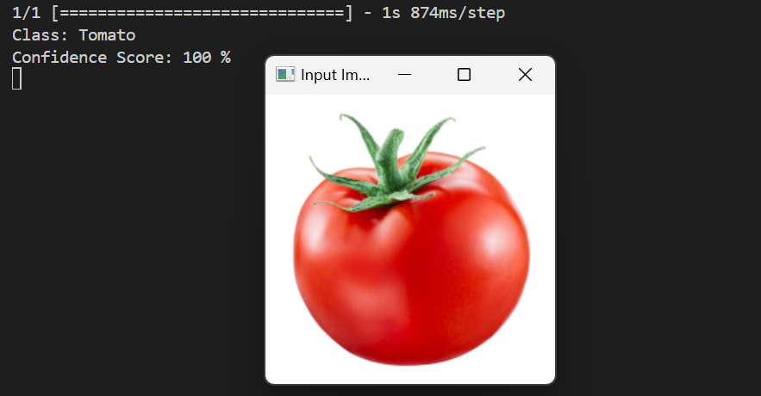

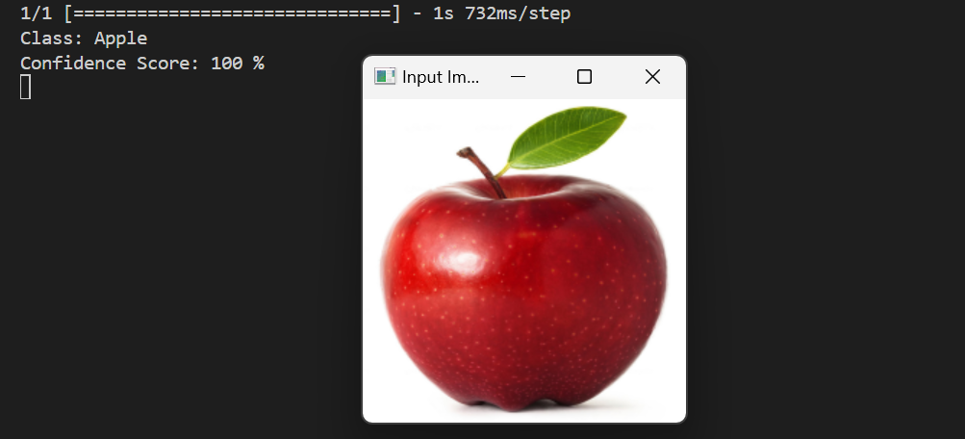

1. **Stage 2**: Use the corresponding ripeness classifier per fruit

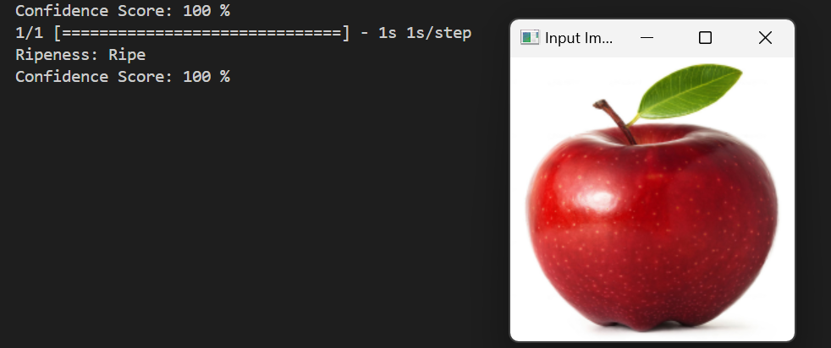

Reminder:

* Some computers run the tensorflow on Vscode only compatible with the lower version from the keras.h5 from Teachable Machine. In our case, the code can not run on the latest version 2.19.0 of Tensorflow. We instead use version 2.12.0
* The name of the python file must not be “[Keras.py](http://keras.py)” else it will cause error